Dynamicke smerovanie

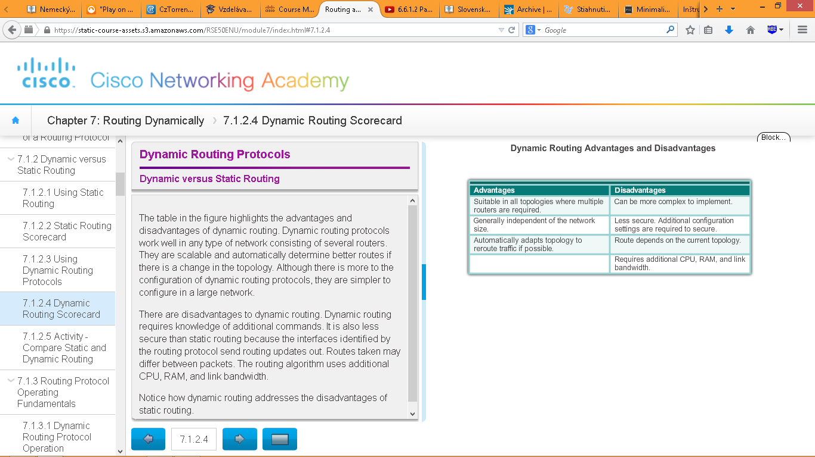

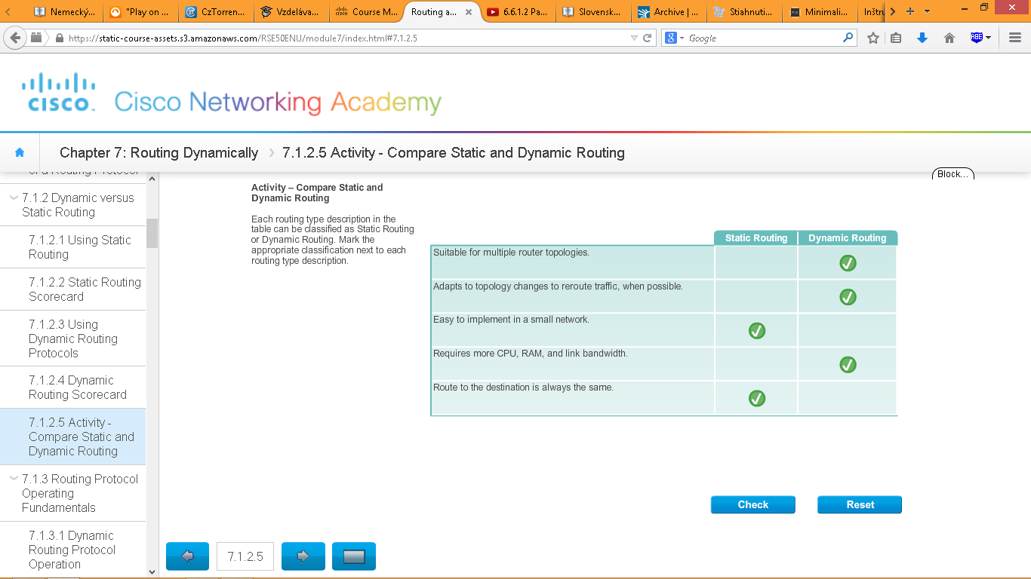

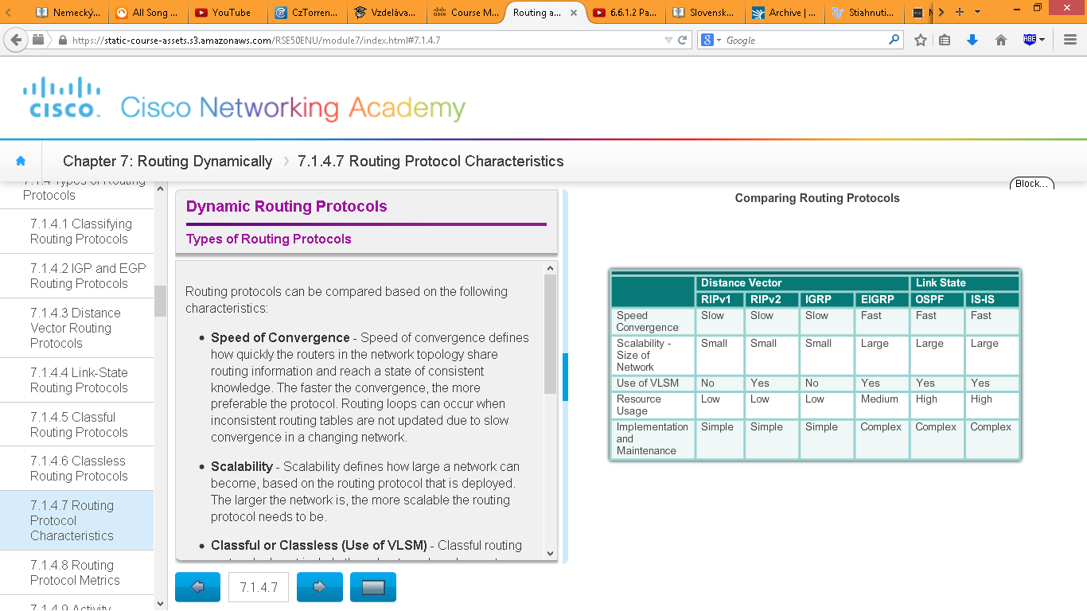

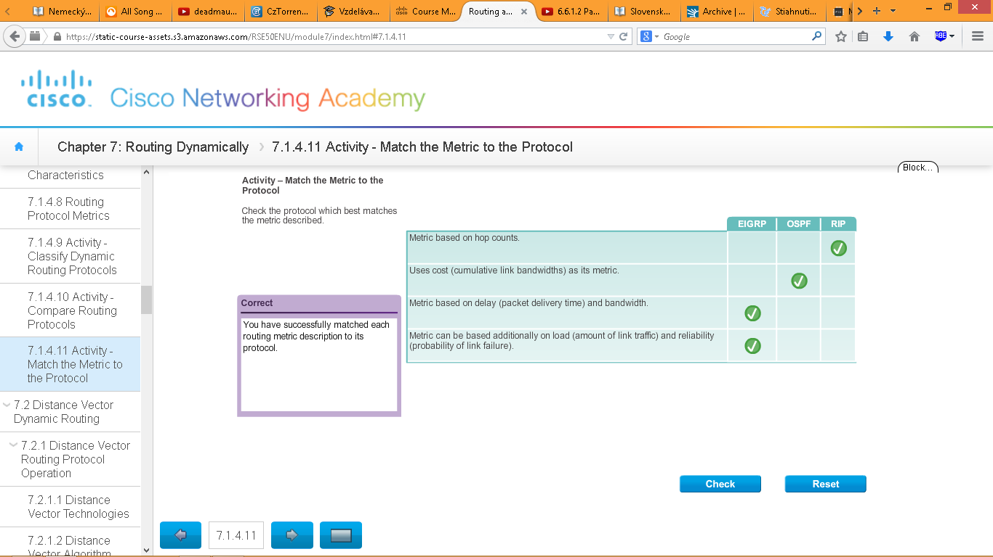

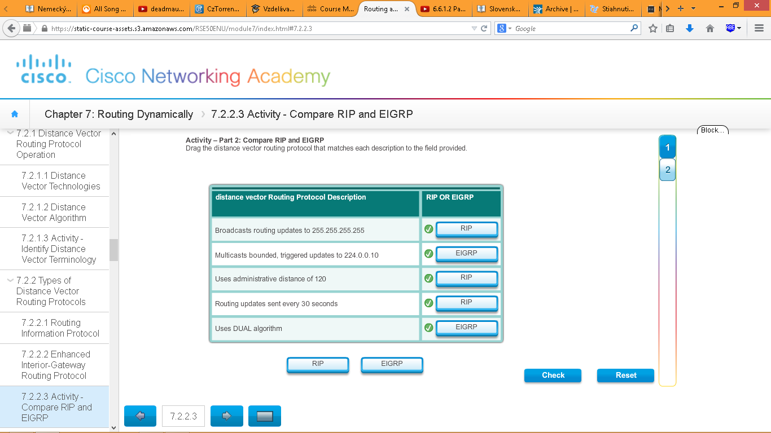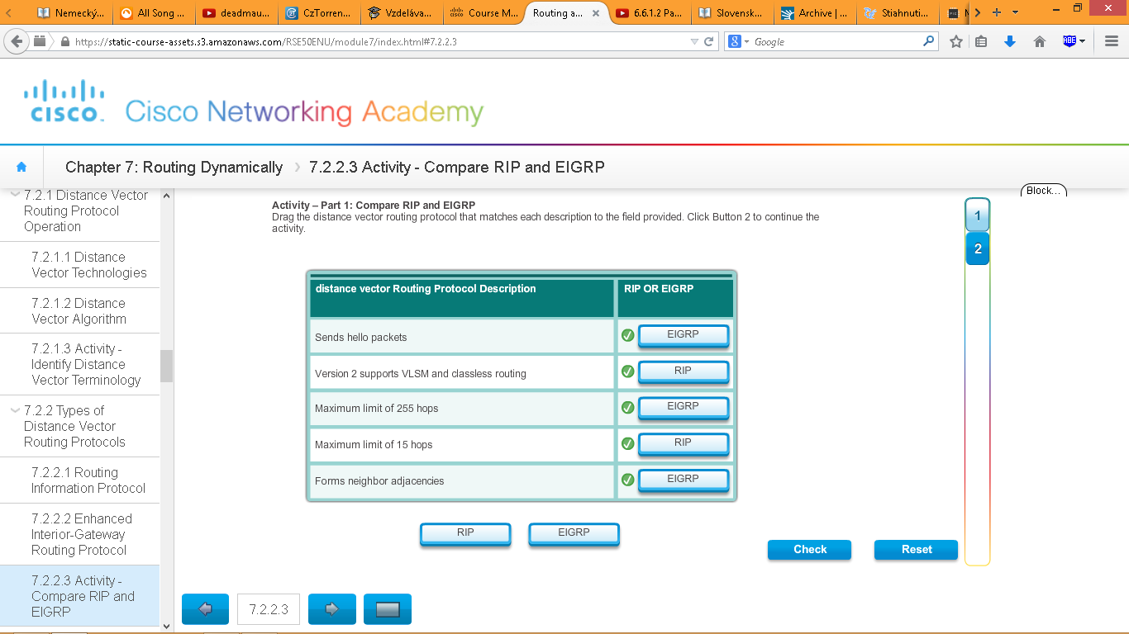

**RIP and RIPng Routing**

To enable RIP, use the **router rip** command, to disable and eliminate RIP, use the **no router rip** global configuration command.

To enable RIP routing for a network, use the **network** *network-address* (napr. **network 192.168.1.32**)

the **network** command is used to advertise the R1 directly connected networks.

The **show ip protocols** command displays the IPv4 routing protocol settings currently configured on the router. This command is also very useful when verifying the operations of other routing protocols (i.e., EIGRP and OSPF).

**show ip route** command displays the RIP routes installed in the routing table. 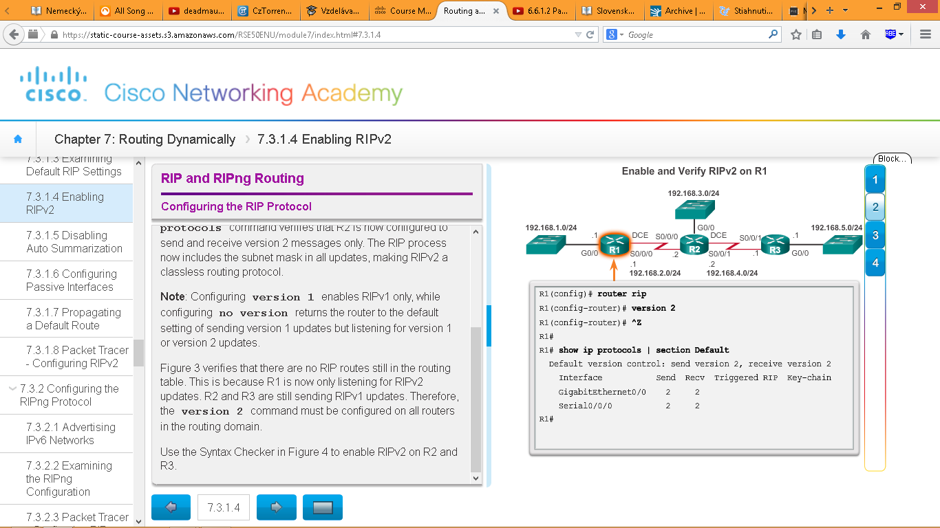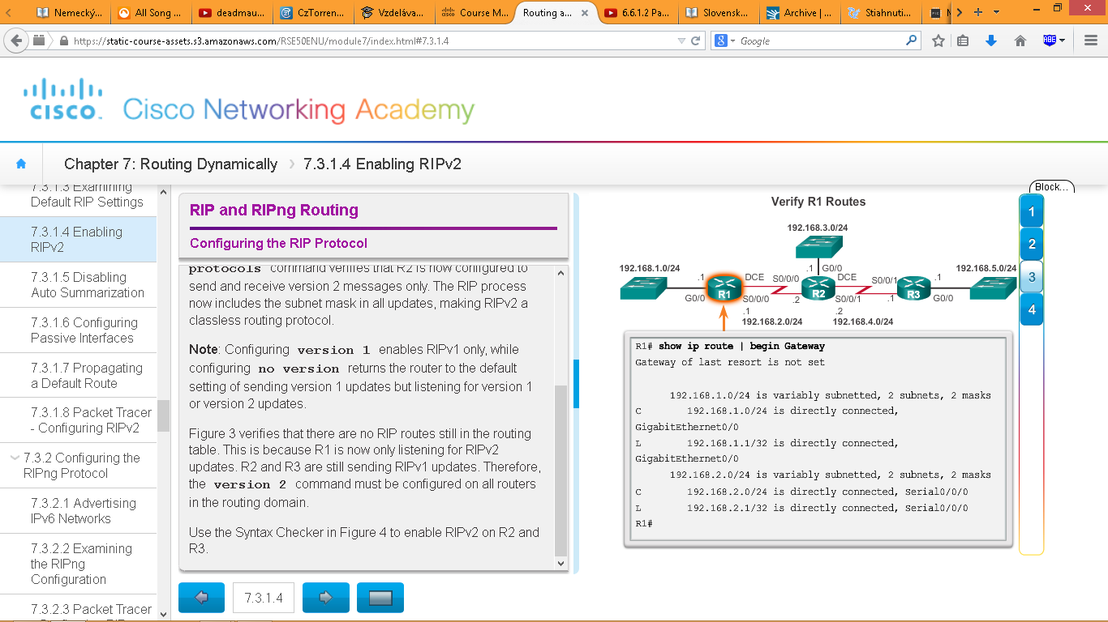

Prikazy na zapnutie RIP-ka:

* router rip
* version 2
* end
* show ip protocols
* show ip route

automaticku sumarizaciu pre RIPv2 treba na routri vypnut, aby obsahovala v jeho aktualizaciach vsetky podsiete a ich prislusne masky. Automaticka sumarizacia sa vypina prikazom **no auto-summary** (ziadny auto somari)

Kedy nastavit interfejs ako pasivny:

RIP updates really only need to be sent out interfaces connecting to other RIP enabled routers.

For instance, refer to the topology in Figure 1. RIP sends updates out of its G0/0 interface even though no RIP device exists on that LAN. R1 has no way of knowing this and, as a result, sends an update every 30 seconds. Sending out unneeded updates on a LAN impacts the network in three ways:

Wasted Bandwidth - Bandwidth is used to transport unnecessary updates. Because RIP updates are either broadcasted or multicasted; therefore, switches also forward the updates out all ports.

Wasted Resources - All devices on the LAN must process the update up to the transport layers, at which point the devices will discard the update.

Security Risk - Advertising updates on a broadcast network is a security risk. RIP updates can be intercepted with packet sniffing software. Routing updates can be modified and sent back to the router, corrupting the routing table with false metrics that misdirect traffic

Use the passive-interface router configuration command to prevent the transmission of routing updates through a router interface, but still allow that network to be advertised to other routers. The command stops routing updates out the specified interface. However, the network that the specified interface belongs to is still advertised in routing updates that are sent out other interfaces.

To propagate a default route, the edge router must be configured with:

* A default static route using the **ip route 0.0.0.0 0.0.0.0** *exit-intf next-hop-ip* command.
* The **default-information originate** router configuration command. This instructs R1 router to originate default information, by propagating the static default route in RIP updates.

RIPng (RIP next generation) konfiguracia

-smerovaci protokol pre IPv6

To enable an IPv6 router to forward IPv6 packets, the **ipv6 unicast-routing** must be configured.

Po zapnuti IPv6 smerovania mozme zapnut RIPng smerovaci protocol prikazom **ipv6 rip RIP-AS enable**

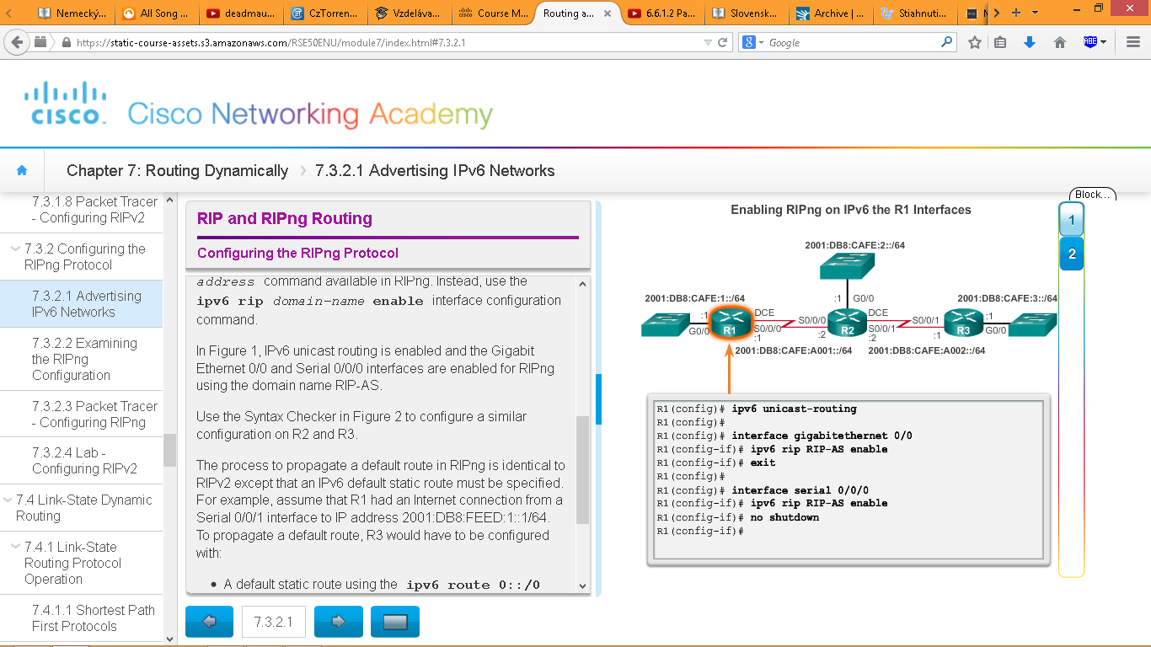

Unlike RIPv2, RIPng is enabled on an interface and not in router configuration mode. In fact, there is no **network** *network-address* command available in RIPng. Instead, use the **ipv6 rip** *domain-name* **enable** interface configuration command.

* A default static route using the **ipv6 route 0::/0 2001:DB8:FEED:1::1** global configuration command.
* The **ipv6 rip** *domain-name* **default-information originate** interface configuration mode command. This instructs R3 to be the source of the default route information and propagate the default static route in RIPng updates sent out of the configured interface.

Overenie funkcnosti

**show ipv6 protocols, show ipv6 protocols rip**

**show ipv6 route, show ipv6 route rip**

LINK STATE PROTOKOLY

Link-state routing protocols are also known as shortest path first protocols and are built around Edsger Dijkstra's shortest path first (SPF) algorithm. The SPF algorithm is discussed in more detail in a later section.

Just like RIP and EIGRP, basic OSPF operations can be configured using the:

* **router ospf** *process-id* global configuration command
* **network** command to advertise networks

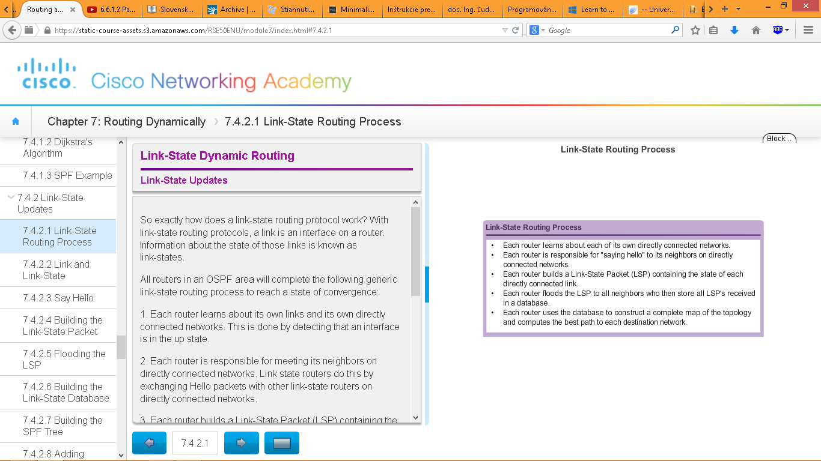

Link state routing process is the same for both OSPF for IPv4 and OSPF for IPv6

the link-state information includes:

* The interface's IPv4 address and subnet mask
* The type of network, such as Ethernet (broadcast) or Serial point-to-point link
* The cost of that link
* Any neighbor routers on that link

**Note**: Cisco’s implementation of OSPF specifies the OSPF routing metric as the cost of the link based on the bandwidth of the outgoing interface. For the purposes of this chapter, we are using arbitrary cost values to simplify the demonstration.

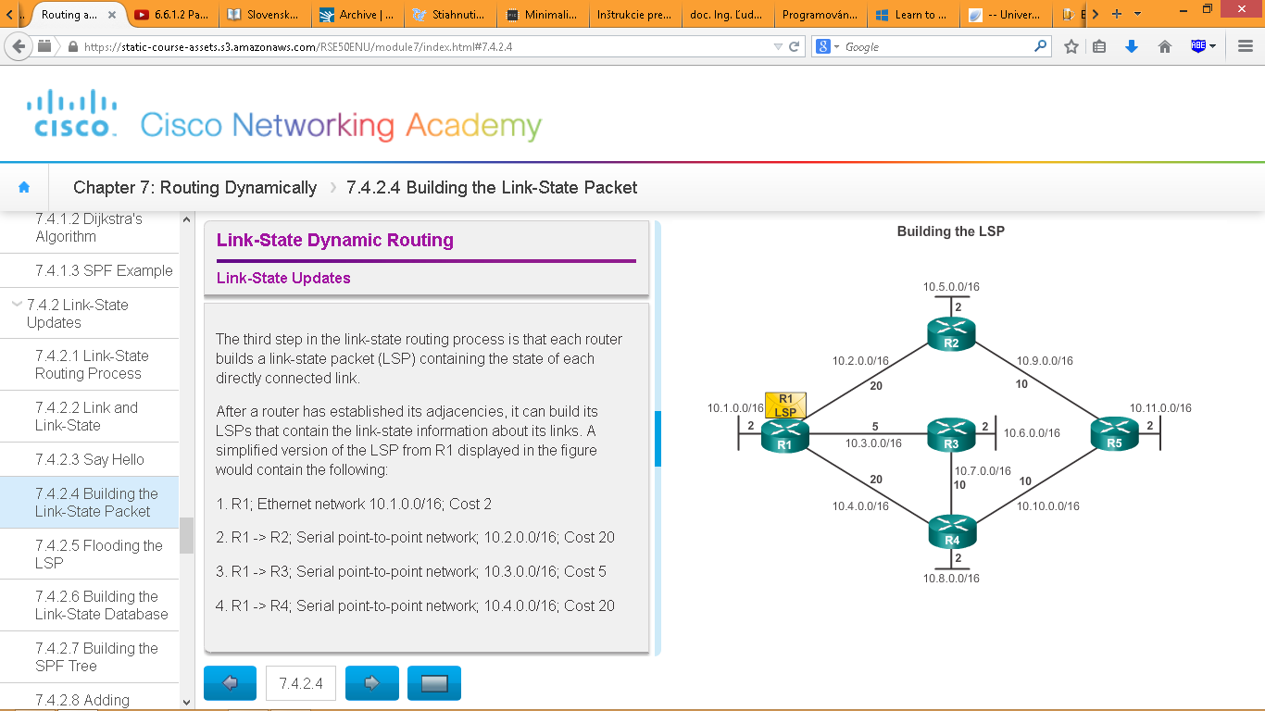

## Link-State Updates

The first step in the link-state routing process is that each router learns about its own links, its own directly connected networks.

The second step in the link-state routing process is that each router is responsible for meeting its neighbors on directly connected networks via “Hello” packets :D

The third step in the link-state routing process is that each router builds a link-state packet (LSP) containing the state of each directly connected link.

The fourth step in the link-state routing process is that each router floods the LSP to all neighbors, who then store all LSPs received in a database. It immediately sends that LSP out all other interfaces except the interface that received the LSP. Sequence numbers and aging information are helping the router to keep only the most current information in its link-state database

The final step in the link-state routing process is that each router uses the database to construct a complete map of the topology and computes the best path to each destination network.

**Vyhody Link-State protokolov**

-Builds a Topological Map

-Fast Convergence

-Event-driven Updates

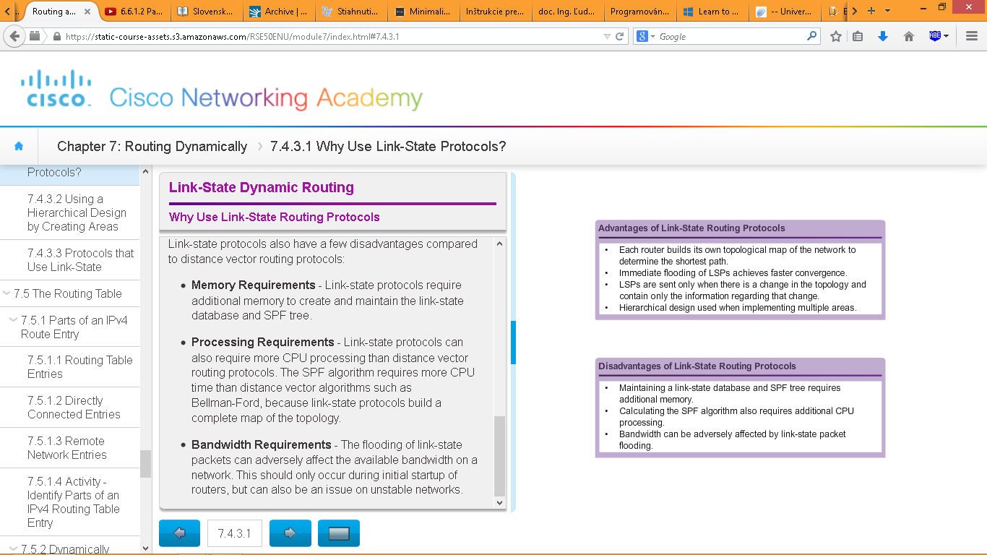-Hierarchical Design

**Nevyhody Link-State protokolov**

-Memory Requirements

-Processing Requirements

-Bandwidth Requirements



When there is a change in the topology, only those routers in the affected area receive the LSP and run the SPF algorithm.

Zaznam routovacej tabulky

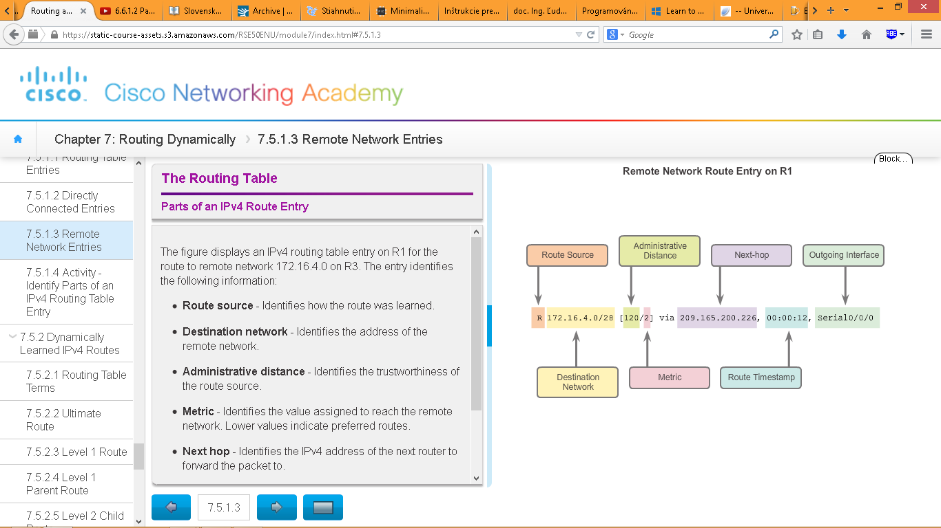

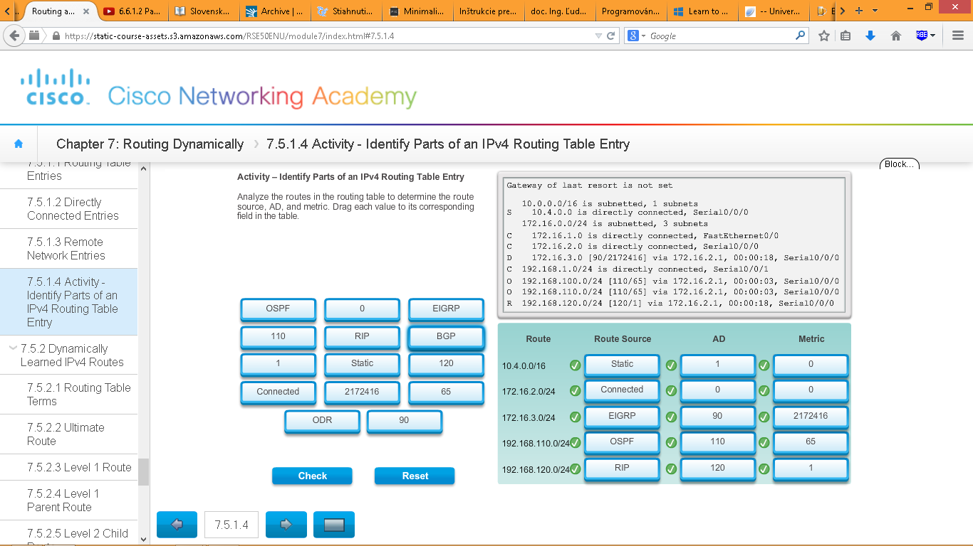

Typy dynamicky naucenych ciest v smerovacej tabulke

**Ultimate route**

An ultimate route is a routing table entry that contains either a next-hop IPv4 address or an exit interface.

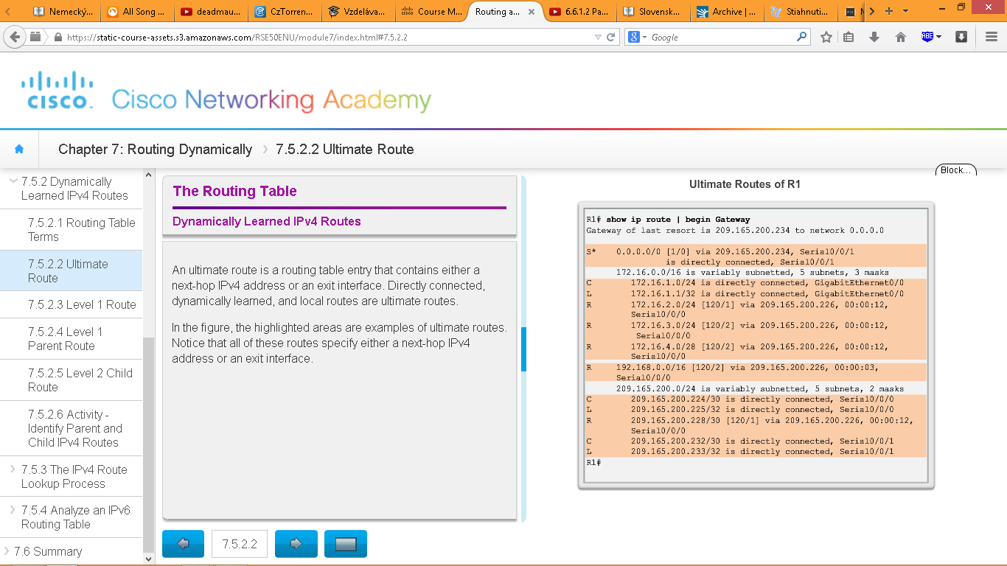

**Level 1 route**

A level 1 route is a route with a subnet mask equal to or less than the classful mask of the network address. Therefore, a level 1 route can be a:

Network route - A network route that has a subnet mask equal to that of the classful mask.

Supernet route - A supernet route is a network address with a mask less than the classful mask, for example, a summary address.

Default route - A default route is a static route with the address 0.0.0.0/0. 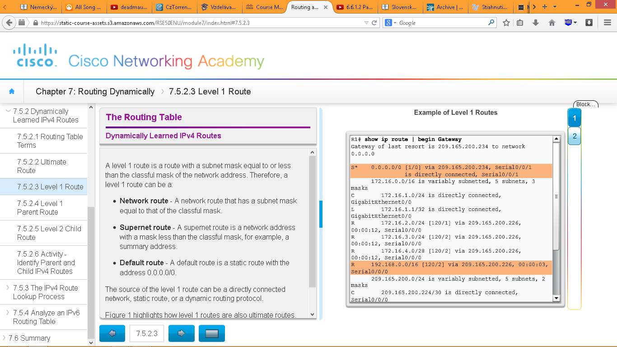

**Level 1 parent route**

level 1 parent route is a level 1 network route that is subnetted. 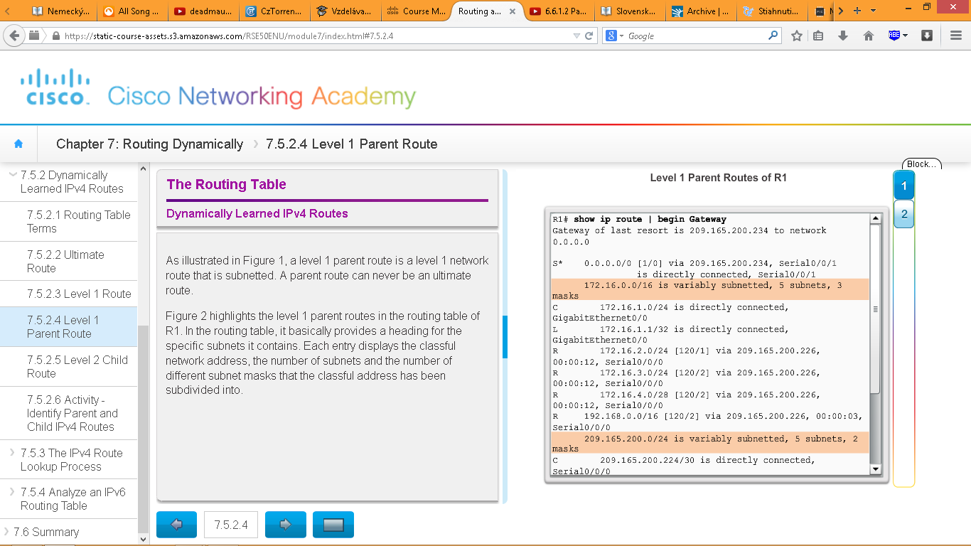

**Level 2 child routes**

A level 2 child route is a route that is a subnet of a classful network address. As illustrated in Figure 1, a level 1 parent route is a level 1 network route that is subnetted. A level 1 parent routes contain level 2 child routes, as shown in Figure 2.

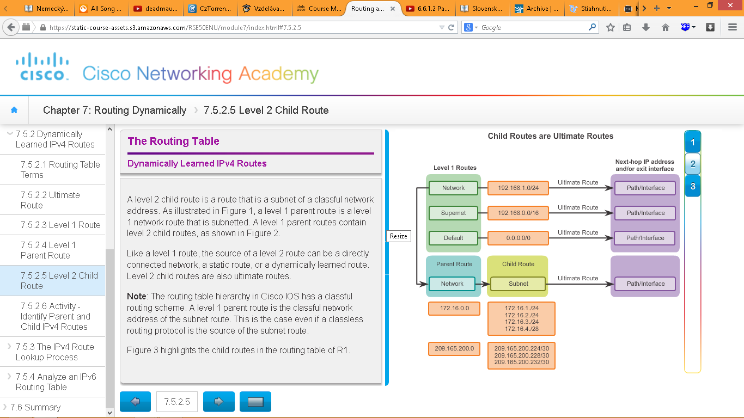

**Zhrnutie typov adries v smerovacej tabulke**

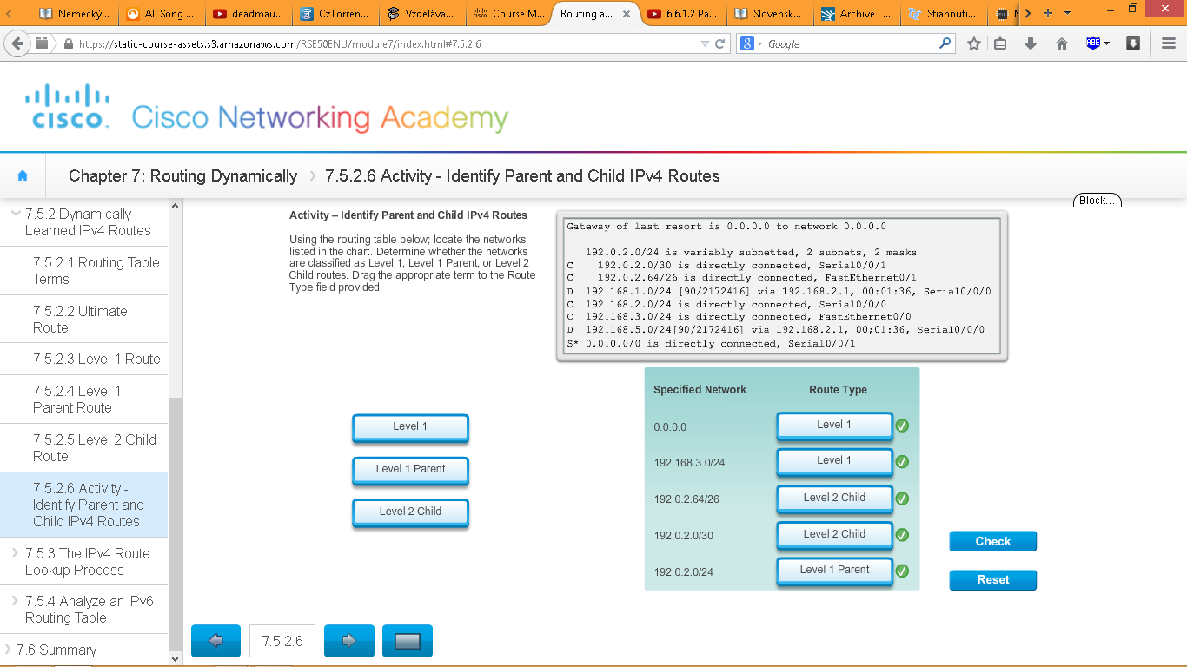

What is meant by the router must find the best match in the routing table? Best match is equal to the longest match.

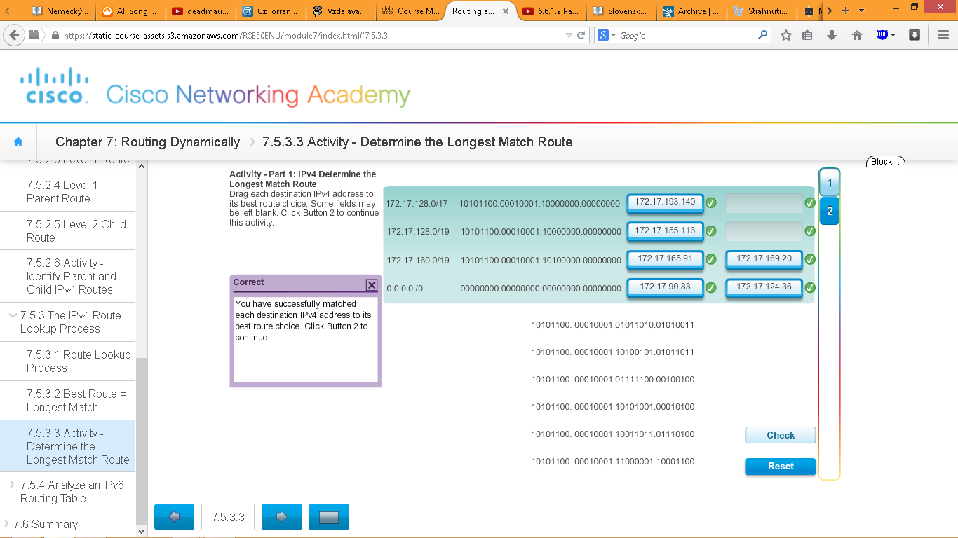

**IPv6 smerovacia tabulka**

* Priamo pripojene siete

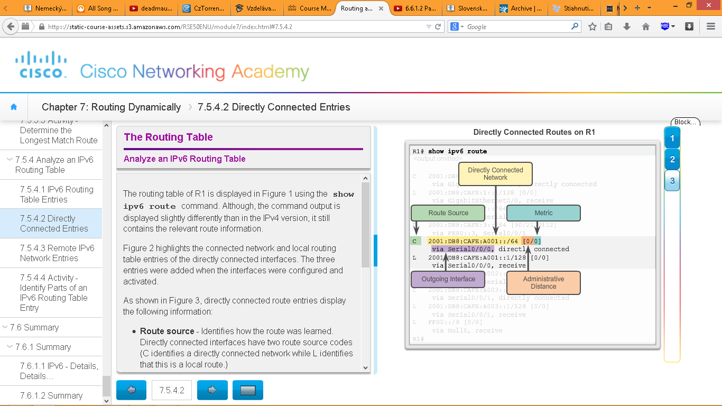

**show ipv6 route** – ukazeipv6 smerovaciu tabulku

* Vzdialene siete

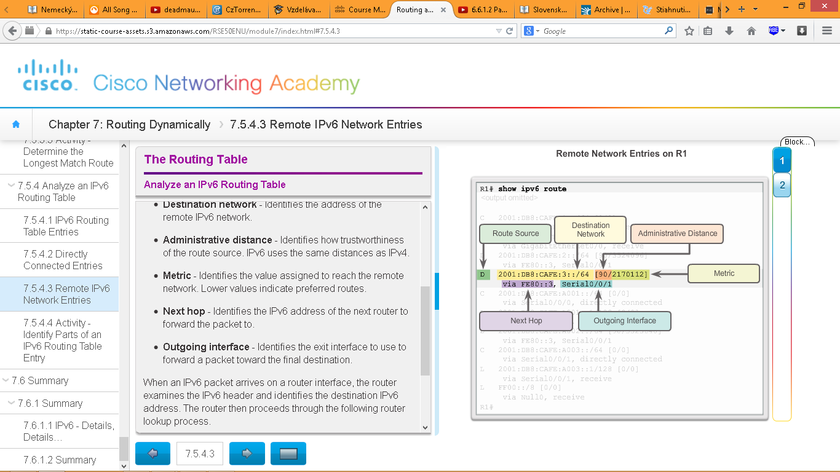

Otazky z testu

What is different between IPv6 routing table entries compared to IPv4 routing table entries?

By design IPv6 is classless so all routes are effectively level 1 ultimate routes.

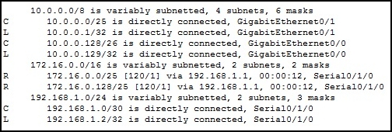

Refer to the exhibit. Based on the partial output from the show ip route command, what two facts can be determined about the RIP routing protocol? (Choose two.)

RIP version 2 is running on this router and its RIP neighbor.

The command no auto-summary has been used on the RIP neighbor router.

The command "version 2" is used in RIP router configuration mode to enable the sending of subnet masks with the routing updates.

Which route will a router use to forward an IPv4 packet after examining its routing table for the best match with the destination address?

a level 1 ultimate route

When configuring RIPng, the "default-information originate" command instructs the router to propagate a static default route.

Which two requirements are used to determine if a route can be considered as an ultimate route in a router’s routing table? (Choose two.)

contain a next-hop IP address

contain an exit interface

A **stub network** has only one default path to non-local hosts and no outside network knowledge. Non-local stub network traffic uses a single logical path when traveling in and out of the network. A good stub network analogy is an island that relies on a bridge as the sole mode of transportation to the mainland. Or, there may be multiple bridges, but each bridge only leads to a single point on the mainland.